Chapter 1. The End. 1924
1879 words, 300 words/pg, ~6 pages

Dinner at the rooming house had been quieter than usual. Harold hadn’t joined them, which was unusual. In fact, no one had seen him since yesterday morning. Mary, the landlady, and George, one of the other boarders, went upstairs to check on him. George knocked on his door. No answer. George looked at Mary with an unspoken, “Should we…?”

Mary opened the door just a crack, hesitating to intrude .“Harold? Are you well?” No answer. George peered in, and saw Harold, slumped over his table nestled in a puddle of radio parts, lifeless.

George ran down the stairs to fetch a police officer. Mary waited in the front room, dazed and distressed. She’d enjoyed Harold’s quiet company and sly wit. He was charming, always asking after her. Unlike most men she’d known, he didn’t talk only about himself. He seemed genuinely interested in her. Come to think of it, she didn’t know much about him. And what she knew—or thought she know—didn’t add up. Just that he didn’t seem like the other men on this side of Pittsburgh. He was soft-spoken, unfailingly gracious.

Mary knew she was fortunate to have this house, but it was wearisome being a landlady. Her husband, Henry, had died four years ago. After years of working at the steel works, he was worn out at 46 years old. He was no match for the pneumonia that left Mary a widow. Fortunately for Mary, they had owned their home, but that was all they had. Becoming a landlady was her only practical option. Some boarders were a pleasure, but not most of them. Harold who had moved in about a year ago was one of her favourites. Most of the time. He often met her at the door and helped carry her packages up the stairs, and always greeted her the same way, “And how goes my beautiful friend, Mrs. Mary Oates, today?”
Shortly after they first met, he’d told her that his mother’s name was Mary, and that his sister’s name was Mary Amelia, and that he’d named his daughter Nina Mary. “So you see, Mrs. Oates, I am terribly fond of Mary’s.” He had never talked about the mother of his daughter. Mary wondered what had happened to her, but she was not the sort to pry. At least, not directly. She had, in truth, once peeped into Harold’s room when he was out at work. She’d seen the yellowed news clipping from 1914 pinned to the wall that reported on the wedding of Nina Mary Grahame Joy and Robert Kay Gordon in York Mills, Toronto, Canada. The announcement described it as an “exceedingly pretty wedding.” Mary thought it sounded awfully ‘high hat.’ She was curious to note that, although the bride’s mother was Mrs. Harold Joy, there was no mention of the bride’s father. Hmm.
Half an hour later, George returned with Officer O’Malley. He and Mary led him upstairs to Harold’s room. The officer remarked that the little warming stove was still lit. Mary and George been too stunned to notice this when they found Harold. Carbon monoxide poisoning was a hazard in rooms like these, where tenants sometimes used a rubber hose to attach a stove to the gas outlet. Harold’s cause of death was thus presumed to be carbon monoxide poisoning. Officer O’Malley had seen this before.

Besides the radio parts on the table, there were clippings from Canadian newspapers. One of them reported on a Lieutenant Colonel Douglas Joy, flying on the inaugural flight of the Canadian aerial mail service. Guessing that this Colonel was probably a relative, Officer O’Malley collected the papers, then asked George to help him wrap up and carry my great grandfather’s body downstairs, so he could be taken to the morgue. O’Malley did not collect the empty whiskey bottles.

George was sad. Harold had been good company, although he hadn’t known him terribly well. One of the few things that he knew were that Harold came from Canada, that he had worked as an electrician at the Edgewater Steel Company in Oakmont, and that he was a drinker—hardly uncommon in hard-drinking Pittsburgh. This was the Prohibition Era, whose main effect, ironically, was to spawn thriving businesses for bootleggers and the speakeasy owners, frequented by George and Harold, as well as by Officer O’Malley and his colleagues who generously enjoyed their free drinks as a thank you for not interfering with business at the speakeasy.

At the morgue, the coroner, Dr. McGregor, got in touch with H. W. Earl who was Harold’s supervisor at the Edgewater Steel Company. Dr. McGregor asked Mr. Earl to identify the body, so that he could notify Harold’s family. Mr. Earl was quite surprised to hear this.

Oh? So, you’re contacting his family? But Mr. Joy told us at work that his family and friends all thought he had been killed in a railway accident. He told us that he’d been reported dead in the Canadian newspapers.
Well! Replied Dr. McGregor. I imagine they’ll be quite surprised to receive my letter informing them that he’s died a second time!
The next day, Dr. McGregor sent a letter addressed to Colonel Douglas Joy at Camp Borden in Barrie, Canada. Although Colonel Douglas Joy hadn’t lived there for some years, the letter eventually found him in Toronto. Whereupon he passed it on to his younger brother, Grahame, who being a lawyer, was better at this sort of thing than Douglas. Fortunately, they had friends in both Toronto and Pittsburgh to help sort out their father’s affairs, such as they were.
Douglas and Grahame Joy, Frank Thomson, and Helen Grace Cassells were all friends from their wonderful summers of roughing it in the bush at The Inlet in the Georgian Bay north of Toronto. Helen Cassels lived in Toronto and her father, Dick Cassels, was one half of the Cassels & Cassels law firm.
Most conveniently, he was also the lawyer for the Canadian business interests of the Thomson & Sproull family insurance firm in Pittsburgh, which was where their friend Frank Thomson worked.
Grahame sent money to Dick Cassels, their Toronto lawyer friend, who then coordinated the burial with Frank Thomson in Pittsburgh. Grahame paid for a new suit, casket, embalming, hearse, newspaper notice, and the grave at the new Woodlawn Cemetery, just outside of Pittsburgh.
Frank assured Grahame that Woodlawn was one of the nicest new cemeteries near Pittsburgh. Harold would be given a decent burial. In an odd happenstance, far away in his birth home of Leeds, England, Harold’s parents and his brother, Frank, were buried in a cemetery of almost the same name – Lawnswood Cemetery. And thus a tiny, invisible thread stretches across the Atlantic Ocean from Woodlawn to Lawnswood; from Pittsburgh, USA to the Headingley neighbourhood of Leeds, UK where Harold was born.
---will insert images of the letter & cemetery card---
Harold’s oldest son, Douglas Grahame Joy, my grandfather, refused to attend his father’s funeral. He could not forgive Harold for having abandoned the family so many years ago. Only Harold’s youngest son, Grahame, attended the funeral. Nina was the eldest of Harold’s children, and the one who remembered her father best, but she was living far away in Alberta. A trip to Pittsburgh would have been prohibitively expensive for the wife of an English professor and mother of three young boys. Not to mention the four days and at least two different trains it would have taken her to get to Pittsburgh. She stayed home.
Many decades after Harold’s death in the Pittsburgh rooming house at 321 Penn Avenue, Nina would write a wonderful memoir brimming with reverence for the accomplishments of her mother, the spirited and accomplished Jean Hannah Joy, who managed to thrive despite the heartbreak and hardship of being abandoned by her ne’er-do-well husband, Harold Holt Joy.
In contrast to Jean Hannah’s bright light, nothing much was known about Harold Holt Joy. My grandfather was one of the three children he abandoned. Family lore had it that Harold had been a ‘drunk’ who had died as a pauper in Pittsburgh, and that he was the black sheep of a wealthy family back in England. He’d run afoul of expectations and was disposed of in Canada.

Harold’s siblings lost track of him long before he died. The records left by their descendants summarized Harold’s life in just three words, “gone to Canada.” Harold was thus relegated to the dust bin of bad memories.
He left this world in 1924, almost without a trace. There is only one known picture of him, no letters and other than a few intriguing comments, no good stories.

Harold was born into a privileged life, but things went terribly wrong for him. Was he a feckless soul who earned his fate? Or, was he just a superfluous son of the Industrial Revolution beset by a series of unfortunate events beyond his control? What were the demons that he couldn’t outrun?

What follows is my journey to trace the thread of Harold’s life through the fortunes of his family and the life-molding events that swirled around his world. My portrait of Harold is based on the assumption that, like most of us, he just tried to do his best. And knowing that, despite it all, my great grandmother, Jean Hannah Joy, loved him until she died. Her last words to her beloved daughter Nina were, “You are so like your dear father.” Even for those of us with clear ambitions, our lives tend to unfold in unexpected ways. And so it was with Jeanie and Harold.
This story has sad parts, but it’s also a love story with a fairly happy ending.

Questions.
- How best to introduce the relationship of the narrator? Is it interesting? Extraneous? When best to introduce, if at all?

---END OF CHAPTER DRAFT---
----NOTES maybe use, maybe not---

One mystery is
How did Harold end up in Pittsburgh and how did Frank Thomson come to be connected with Harold Joy? Grahame (Harold’s son) and Frank were the same age and would have known each other from the magic years at Nares Inlet. He might have contacted Frank. Grahame was friends with Dick Cassels’ daughter, Helen Grace Cassels, so he would have known that the Cassels & Cassels Law Firm were the lawyers for the Thomson’s insurance clients in Canada.
This doesn’t explain why Harold ended up in Pittsburgh. Is it possible that Jean had contacted George Thomson to help Harold find a job? Since Jean died in 1919, this would have had to have happened before then. This is unlikely because the only letters reported to be found in the room where Harold died were from Harold’s sons-- none from his daughter Nina or wife Jean. A letter from a wife would certainly have been mentioned.
Pittsburgh was awash in alcohol. A terrible place for an alcoholic to wind up. The word speakeasy comes from Pittsburgh. Police allowed them, in fact, patronized them.
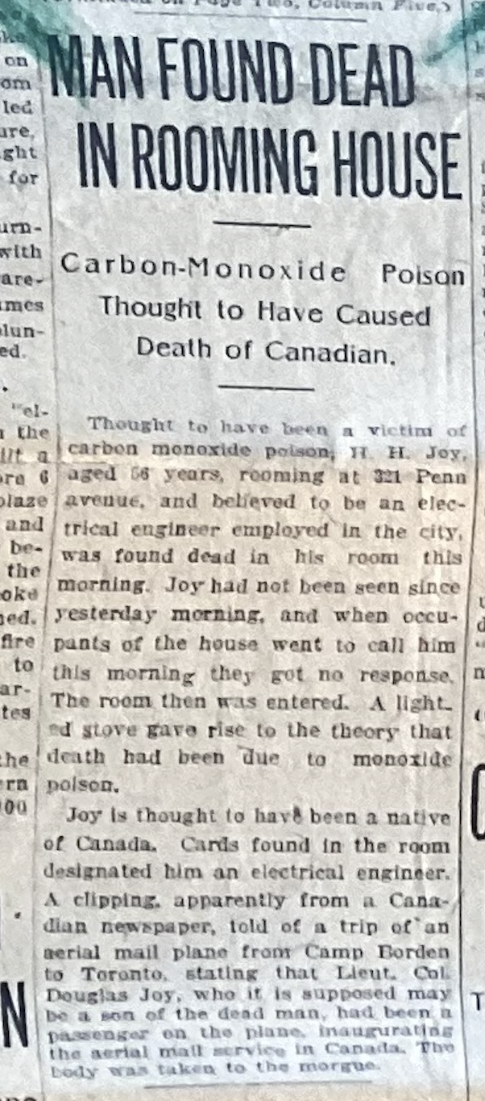

Oakmont would have been 2 hours away by streetcar. The rooming house was 321 Penn Ave. Why so far away?
Bootleggers were called that because they initially concealed flasks of liquor in the upper part of their boots, particularly when trading with Native Americans during the 1880s. The term "bootleg" referred to the area of a boot that covers the calf. It became widely used during Prohibition
According to some accounts, the word speakeasy came from “speak-softly shops,” which was slang for illegal drinking establishments. The name referenced the need for secrecy; customers were asked to speak quietly while inside to avoid detection.
Frank Dickson Thomson (1891-1989) was the son of George Napier Thomson (1848- ) & Jemima. They emigrated to Kentucky where Frank was born, and later moved to Pittsburgh. George Napier Thomson bought islands in Nares Inlet at about the same time that Jean Joy, (mother of Douglas, Grahame, and Nina), bought her three islands. George Thomson was 11 years older than Jean. They certainly would have known each other. Both Frank and Grahame were 33 years old when Harold died. It’s likely they had met each other up at Nares Inlet. Grahame had probably also met Dick Cassels, although Dick was 28 years older than him. Dick’s daughter Helen Grace Cassels was just 2 years younger than Grahame. Helen Grace and Alan Stewart were the parent of Ian Stewart and John Cawley’s mother (name?)
Richard (Dick) Scougall Cassels (1859-1935). Dick started the law firm Cassells & Cassels with his brother, Hamilton Cassels. Dick was an excellent amateur photographer

